Seniors

- Send electronic Abstract/Bios to Courtney.Bennett@sarasotacountyschools.net by March 11th 2019
- Title
- Researcher Name:
- Mentor:
- Abstract
- Awards and Honors:
- Motivational/Inspirational/Favorite Quote
- Picture – Include a picture of yourself.
- Correctly formatted
  - Look at previous program to see how it should look
  - Copy and paste over the template from last year

PLEASE USE THE TEMPLATE BELOW.

The Effect Different Dosages of an ADHD Medication have on the Heart Rate of Daphnia (Calibri – 20 pt font)

Researcher: Alyssa Heere (Times New Roman – 14 pt font)
Mentor: Dr. Miguel Alvarez and Mrs. Jodi Costa (Times New Roman – 14 pt font)
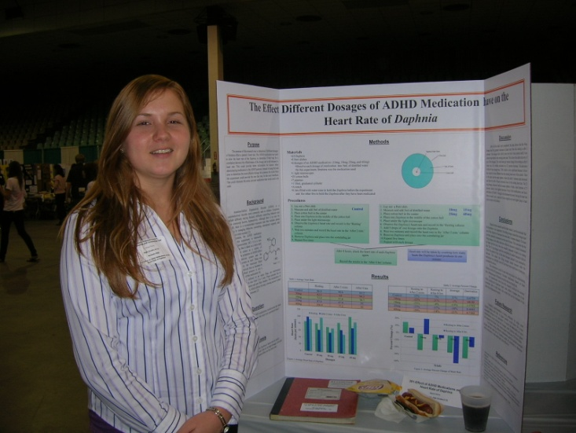
Attention-Deficit/Hyperactivity Disorder (ADHD) is a common neurobehavioral childhood disorder, with symptoms such as hyperactivity. There are other symptoms that affect the cardiovascular nervous system as well. The purpose of this research was to determine which dosage of an ADHD medication, Strattera, causes the heart rate of Daphnia to safely decrease the most over a period of time. Daphnia are microscopic crustaceans that have a transparent exoskeleton, and Strattera, chemically known as atomoxetine HCl, is a daily ADHD medication. The medication was used to slow the heart rate of the Daphnia and to determine if there was a correlation between the dosage amount and the heart rate. The dosages included 10mg, 18mg, 25mg, and 60mg. To show how the medication changes the heart rate over time, it was taken two minutes after administration and then again 8 hours later. Based on the results, the hypothesis was proven correct, the 60mg dosage would cause the heart of the Daphnia to initially decrease the most and then slowly rise back to normal during the 8 hour period. For this dosage, there was a 21 percent decrease in heart rate from before to after 8 hours. The 60mg dosage was the most effective and showed the safest recovery compared to the other dosages. (Times New Roman – 12 pt font)

Awards and Honors (Time New Roman – 20 pt font)
- 1st place winner for Medicine and Health in the Sarasota County Regional Science
Fair 2010
- Dart Foundation Award for Medicine and Health 2010
- U.S. Army Award for Life Sciences 2010
- 2nd place winner for Medicine and Health in the Sarasota County Regional Science Fair 2008 (Times New Roman – 12 pt font)

“If you do not hope, you will not find what is beyond your hopes.” -St. Clement of Alexandra (Times New Roman -14 pt font)

